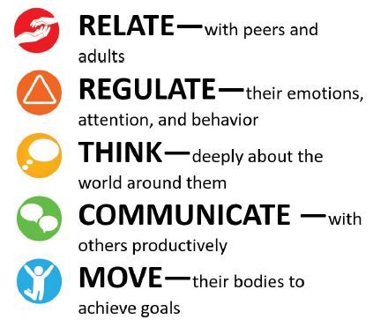This year is just flying by! Can you believe it is May already?!
May
2023
Streamin3 Core Skills

Upcoming Closings:
May 29th – Memorial Day
June 19th – Juneteenth
July 4th – Independence Day
August 18th – Cleaning Day
************************
Upcoming Events:
Mother’s Day Tea – May 5th
Teacher Appreciation Week –
May 8th – 12th
Rev Your Bev Week –
May 8th – 12th
PreK-4 Graduation 3:00 –
May 12th
Summer Session Starts – June 5th
HUELC 15th Anniversary –
June 9th
OPEN HOUSE & VENDOR FAIR
9:00 – 2:00
Dogs for Dads Lunch – June 22nd
Community Helper Fair –
June 23rd 9:30 – 11:00

The children have been enjoying spring crafts and lots of outside time!
You can help by making sure your child has extra clothes here every day. We go outside even when it is cool, even if it is only for a few minutes!
Upcoming closings are listed for you to the right. Please, remember if you know your child will not be here let us know so we can plan staff accordingly.
Please remember to check and see that your child has everything they may need for the day. This includes extra clothes, sheet, blanket, a cup or bottle – if age appropriate, utensils, if needed for lunch, diapers, wipes, etc. Water bottles are recommended for age 2 and up.
Please let us know if you have any questions or concerns, we can address. You can reach me here most days from 9 – 6 p.m. or by email, phone, or Facebook.
Recent Happenings at Horizons

Last month we had a grand Easter Egg Hunt! Many Thanks to the Horizons Helping Hands group and the UUMC church ladies for organizing that event!
Contact Information

Phone: 804-758-0711
Email: horizonselc4@yahoo.com

This month we have a Mother’s Day Tea on May 5th and PreK-4 Graduation on May 12th!

We are gearing up for our 15th Anniversary here at Horizons on June 9th!! To celebrate we will be posting some videos and pictures of our early years on our Facebook page and our website. Our annual Open House and Vendor Fair will be June 17th! We hope you come join us for food, fun,
vendors, children’s activities, a yard sale, and more!

Later in the month we will be hosting “Dogs for Dads” –
a lunch for Father’s Day! A tentative day has been set
as June 22nd. On June 23rd Our 2nd Annual Community
Helper Fair will be held from 9:30 – 11:00.

As you can see, we have a very busy Spring and start to
Summer! We are looking forward to it! We hope you
are too!

