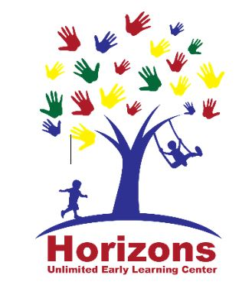
Horizons Unlimited Early Learning Center
March 2024
221 Marston Ave, Urbanna, VA 23175• 804-758-0711
horizonselc4@yahoo.com * fax: 804-597-0006
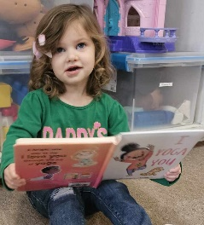  Poem:  “Books”  I like books  I really do.  Books with stories  And pictures, too.  Books of birds  And things that grow.  Books of people  We should know.  Books of animals  And places, too.  I like books  I really do!  -Author Unknown  Song:  “If You’re Ready for a Story”  (tune: “If You’re Happy and You Know It”)  If you’re ready for a story,  come sit down.  If you’re ready for a story,  come sit down.  Let’s all gather near,  so everyone can hear.  If you’re ready for a story,  come sit down.  -Jean Warren |  | Happenings at Horizons
Clothing requests: Spring is right around the corner! The time changes on 3/10 & Spring begins on 3/19. This is a good time to check your child’s cubbie for size and season appropriate clothing. Please remember we go OUTSIDE everyday! Make sure your child is appropriately dressed – including shoes, and has a jacket or sweater available for cool mornings/evenings. Brand new super cute outfits are best kept for home and not daycare/preschool. The art of childhood learning is messy!
General health info: As things start blooming so do allergies, however that does not change our sick policy. There is no way to be 100% sure that profusely snotty noses, goopy eyes, or coughs are allergies and not the beginning of illness. So if your child has diagnosed allergies it is best to keep them on their prescribed medications to prevent frequent send homes for symptoms.
Program News: We have a new substitute teacher! Help us welcome Mrs. Katelynn Todd to our Horizons family!
Other highlights: How are you liking Brightwheel? Do you need any help navigating the app? Ask any staff member or admin and we would love to help you out!! Make sure to check your child’s FEED for updates as well as turn on alerts so you do not miss messages, updates, or reminders.

 |  |  | What We are Exploring:
Infants – 2s are using the Frog Street Curriculum

PreK 3 & PreK 4 – are integrating Streamin3 curriculum components with their own teacher made individualized curriculum.
Upcoming Center wide themes: St. Patrick’s Day, Wind & Weather, and Easter!

 |  | Increase in FEES!
Use of our extra supplies has been increasing! The prices for supplying these items has also increased. Therefore….. our FEES will be increasing as well.
Lunch, extra clothes and sheets/blankets are now $10 per use. Invoices will be applied immediately to Brightwheel. If extra clothes are washed and returned within 48 hours that invoice will be deleted.

UPCOMING EVENTS |  | Looking Ahead:  - May – Mother’s Day Tea (DATE TBA)  - CLOSED 5/27  - June - Summer Session begins 6/3!  Meet our Staff:  - Ms. Liz Organt  Infant Room Aide  Fill-in aide  Retired Nurse  Attends UUMC  Loves Children  Favorite Color: Green  Favorite drink: Chai Tea  Favorite treat: Cheese Puffs  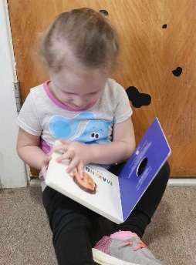  Seasonal Books We Love  - The Wind Blew by Pat Hutchins  - Raindrop Plop by Wendy Lewison  - The Very Hungry Caterpillar by Eric Carle
March:
- Spirit Week: 3/11 – 3/15 M- Wear Pajamas T- Tacky Tuesday W- Superhero Day Th- Wear Green or Yellow F- Show your school spirit!
- Nutrition Class 3/21 @ 5:30 *childcare provided
- CLOSED 3/29: Good Friday
April:
- Child Abuse Awareness & Prevention Month: events TBA
- Last Nutrition class 4/18 @ 5:30 *childcare provided
- Rev Your Bev Week: 4/22 – 4/26
Important Reminders
- Lunch is at 11:00. If your child does not have a lunch here by 10:45 one will be provided for him and you will be charged $10.
- Cell phone policies: Please stay off of your phone during drop off and pick up! Let’s talk about your child today!
- Reminder: Please let us know when your child is going to be absent
- PLEASE use BRIGHTWHEEL for ALL COMMUNICATION and turn on your notifications for the app so you will not miss important messages.
- Teachers will return messages in Brightwheel as they have time up until 6:00 p.m.. They are busy teaching your children and keeping them safe. For urgent matters please contact ADMIN. After hours non-emergency messages may be answered the next day.
You and your child are important to us.
If you ever have a question or concern, please do not hesitate to reach out! Messages to room staff on Brightwheel are seen by Admin as well. Should you desire more privacy you can choose the “Admin Only” option.
Should you wish to share something good a teacher has done
let Admin know or fill out a “High Five!”

